Semantic tableaux method
Based on semantic considerations, a predicate formula belongs to one of the following four classes:
- - class contains conjunctive formulas:
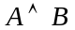, 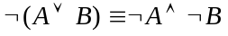, 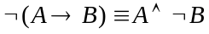
A conjunctive formula is consistent (satisfiable) only if both of its component subformulas are satisfied.

- 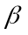 - class contains disjunctive formulas:
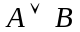, 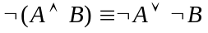, 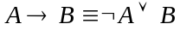
A disjunctive formula is satisfied if at least one of its component subformulas is satisfiable.

- - class contains universal formulas:
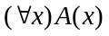, 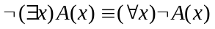

- - class contains existential formulas:
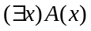, 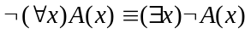

According to these classes there are four decomposition rules, symbolized graphically as follows:

- rules  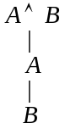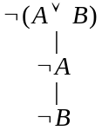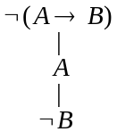 | - rules  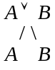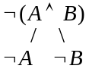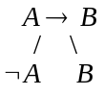
- rules  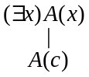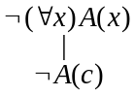 | is a new constant on the branch.
- rules  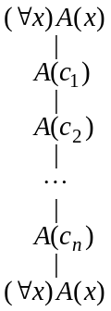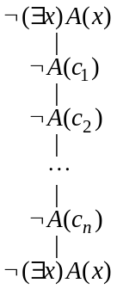 | 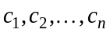 are all the parameters (constants) on that branch and they are used for the instantiation of . If there is no constant on that branch, a new constant is introduced and used for instantiation.

      - The construction of a semantic tableau
To a propositional/predicate formula 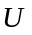 we can associate a semantic tableau, which is a binary tree having formulas in its nodes and it is built as follows:
- the root of the tree is labeled with the initial formula;
- every branch of the tree which contains a formula will be extended with a subtree according to the decomposition rule specific to its class;
- the extension of a branch stops in the following cases:
- if that branch contains a formula and its negation; the branch is marked as closed using the symbol ;
- if all the formulas on that branch are already decomposed or if by decomposing the formulas which are not decomposed yet, no new formulas are obtained.

- A branch of the semantic tableau is called closed (marked by ) if it contains a formula and its negation, otherwise the branch is called open (marked by the symbol ).
- A branch is called complete if it is closed or all the formulas on that branch are already decomposed.
- A semantic tableau is called closed if all its branches are closed.
- If a semantic tableau has at least one open branch, the tableau is called open.
- A semantic tableau is called complete if all its branches are complete.

Recommendations to obtain the simplest semantic tableau (binary tree), with fewest branches:
- apply - rules and - rules which keep one branch before - rules which make a branching;
- apply - rules (introduction of new constants) before - rules which use all the constants on that branch.

A consistent (satisfiable) formula has associated a complete and open semantic tableau. Each open branch provides a partial model of the formula, which covers one or more models (complete models).
An inconsistent formula has associated a closed semantic tableau. All the branches of the semantic tableau are closed, meaning that there is no model of that formula.

The semantic tableaux method is used as a refutation proof method to solve the decision problems in propositional/predicate logic, according to the following theorems.

          - Soundness and completeness of the semantic tableaux method
A propositional/predicate formula is a tautology if and only if there is a closed semantic tableau associated to 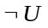.

Let 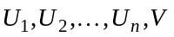be propositional/predicate formulas.
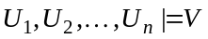 if and only if there is a closed semantic tableau associated to the formula 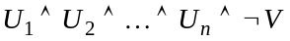.

In propositional logic, which is decidable, the semantic tableau associated to a formula is always finite, therefore we can always decide whether a formula is a tautology or not.

The predicate logic is not decidable, it is only semi-decidable:
- if the semantic tableau associated to the predicate formula 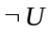 is finite, we can decide whether the formula is a tautology (closed tableau for ) or not (open tableau for ).
- if the semantic tableau of the predicate formula is infinite we cannot decide upon the validity of .

